FINAL BUSINESS REPORT
Airline Flight Delay Intelligence & Operational Performance Analytics
Where delays occur, why they occur, and where management should act first
Item | Details
Project type | Descriptive, diagnostic, statistical and business analytics (no machine learning or AI)
Dataset | 3,000,000 flight records · 32 raw variables (39 after cleaning)
Coverage | 1 January 2019 – 31 August 2023 · 18 airlines · 380 origin airports · 7,785 routes
Tools | Python, NumPy, Pandas, Matplotlib, Seaborn, Tableau
Prepared by | [Your Name]
Date | October 2026

Contents
1 Executive Summary
2 Scope, Data and Method
3 Network Overview
4 Airline Insights
5 Airport and Route Insights
6 Root-Cause Findings
7 Time and Seasonality
8 Tableau Dashboards
9 Recommendations
10 Limitations and Next Steps
Appendix A Airline Scorecard

1 Executive Summary
This report analyses 3 million flights (January 2019 – August 2023) to show where delays occur, how severe they are, what causes them, and which airlines, airports and routes deserve attention first. All figures use transparent rule-based methods and were re-checked against the Tableau data source.
3,000,000  flights analysed (Jan 2019 – Aug 2023) | 18 · 380 · 7,785  airlines · origin airports · routes | 4.26 min  average arrival delay (median: 7 min early)
79.95%  flights on time or early (≤ 15 min late) | 5.84%  severe delays (> 60 min late) | 2.64% · 0.24%  cancellation · diversion rate

Key findings
- The problem is the tail. The median flight arrived 7 minutes early and about 80% were on time or early, but 5.84% of flights were over 60 minutes late (99th percentile: 189 min).
- Airline performance varies widely. Scores range from 0.91 (Hawaiian) to 0.13 (ExpressJet). Of the five largest carriers (65% of flights), Delta scores well (0.78) while United (0.54) and American (0.49) sit in the lower half.
- Delay burden is concentrated in hubs. Ten airports handle 30.5% of departures but about 45% of net arrival-delay minutes; DFW, DEN and ORD carry the most, MCO and EWR have the worst rates.
- Two causes explain three-quarters of delay minutes: late-arriving aircraft (37.7%) and carrier-related causes (36.7%); NAS adds 19.5%, weather 5.9%.
- Summer is the highest-risk period. June (10.1 min) and July (9.5 min) lead; Friday is the worst weekday. Delays have risen every year since 2021.
- Departure punctuality is the main lever: departure and arrival delay are almost perfectly correlated (r = 0.965); distance is unrelated (r = 0.002).

Answers to the project's business questions
Business question | Answer from the data
Which airlines are strongest and weakest? | Strongest: Hawaiian (0.91), Horizon (0.85), Delta (0.78). Weakest: ExpressJet (0.13), Allegiant (0.15), JetBlue (0.22).
Which airports create the greatest delay burden? | By total minutes: DFW (1.05M), DEN (0.86M), ORD (0.72M), MCO (0.61M), LAS (0.47M). By rate among large airports: MCO, EWR, FLL, MIA, DFW.
Which routes need attention? | Routes with ≥ 500 flights: DEN↔ASE, MCO→EWR, MCO→JFK, EWR↔SJU, PNS→DFW, DFW→BHM, DCA↔HPN.
Which causes contribute most? | Late aircraft 37.7%, carrier 36.7%, NAS 19.5%, weather 5.9%, security 0.2% of cause-attributed delay minutes.
Which periods carry the highest risk? | Summer (June–July), Fridays, and December (13.5 min in 2022). 2023 is the worst year so far.
Which segments combine high volume with poor reliability? | Airlines: American, JetBlue and United (SkyWest and Envoy borderline). Airports: DFW, DEN, ORD, MCO, LAS, IAH, EWR, MIA, FLL.
What should management prioritise? | Nine recommendations (Section 9): aircraft-rotation buffers, carrier-process reviews, a summer readiness plan, hub and route watchlists.

2 Scope, Data and Method

2.1 Data
The raw file contains 3,000,000 flight records and 32 variables covering schedule, actual times, delays, cancellations, diversions, distance and five delay-cause fields. The raw data was kept untouched and a separate cleaned dataset (39 columns, including 7 derived fields) was used for all analysis.

2.2 Cleaning decisions
- No duplicates and no invalid cancelled/diverted flags (all values 0 or 1); no negative taxi, air, elapsed-time or distance values.
- Missing values were treated by business meaning, not filled blindly. Arrival delay is missing for 86,198 flights (2.87%), essentially the cancelled (79,140) and diverted (7,056) flights. Delay-cause fields are blank for 82.2% of records because no cause was recorded; they were treated as zero only when summing cause minutes.
- Cancellation code was labelled NOT_CANCELLED for flights that operated; no reason was invented for cancelled flights.
- Derived fields: delay severity class, total cause minutes, year, month, day, weekday, route (origin → destination). Season was derived during the analysis stage.

2.3 Delay severity rule
Flights are classified by arrival delay. Cancelled and diverted flights have no arrival delay and are reported as Unknown, so they are measured separately through cancellation and diversion rates.
Class | Rule (arrival delay) | Flights | % of all flights
On time / early | ≤ 15 minutes | 2,398,513 | 79.95%
Moderate delay | > 15 to 30 minutes | 184,218 | 6.14%
Significant delay | > 30 to 60 minutes | 155,936 | 5.20%
Severe delay | > 60 minutes | 175,135 | 5.84%
Unknown | Cancelled or diverted (no arrival delay) | 86,198 | 2.87%

2.4 Rule-based scoring algorithms
No machine learning is used. Each score is a documented formula; because the project brief does not prescribe weights, equal weights were used as a transparent baseline.
Score | Inputs | Formula | How to read it
Airline Performance Score | Avg arrival delay, severe-delay rate, cancellation rate, diversion rate | Min-max normalised (best = 1), weights 25% each | 0–1; higher = better relative performance
Airport Risk Score | Delayed-flight rate, severe-delay rate, disruption rate (cancellation + diversion) | Min-max normalised, weights 33.3% each | 0–1; higher = higher relative risk
Route Risk Score | Same three inputs at route level | Min-max normalised, weights 33.3% each | 0–1; higher = higher relative risk

2.5 Metric definitions to keep in mind
Rates in the Python analysis use all scheduled flights as the denominator, so cancelled and diverted flights count as not delayed. The Tableau workbook uses slightly different thresholds and weights for some metrics. Both views agree on the main conclusions (Section 4), but the differences matter if the numbers are compared side by side.
Metric | Python analysis | Tableau workbook
Severe delay | Arrival delay > 60 min | Severe flag uses ≥ 60 min; severe rate uses the same > 60 class
Delay frequency | Arrival delay > 0 min | Delay Frequency > 15 min; Delay Frequency Score > 0 min
Airline score | 25% / 25% / 25% / 25%, min-max scaled | 30% delay, 30% severe, 20% cancellation, 20% diversion, scaled 0–100
Route risk | Equal weights, min-max scaled | 40% frequency, 40% severity, 20% disruption; High ≥ 75, Medium ≥ 50

3 Network Overview
Across 2,913,802 flights with a recorded arrival delay, the average flight arrived 4.26 minutes late, but the median flight arrived 7 minutes early. The gap between mean and median shows a right-skewed distribution: many flights run on or ahead of schedule while a small share is delayed for a long time.
Statistic (arrival delay) | Value
Mean / median | 4.26 min / −7 min
Standard deviation | 51.2 min
75th / 90th percentile | 7 min / 36 min
95th / 99th percentile | 71 min / 189 min
Flights delayed more than 180 minutes | 32,263 (1.11% of flights with an arrival time)
Average departure delay | 10.12 min

Delays are created on the ground
Departure delay is almost perfectly correlated with arrival delay (r = 0.965). Taxi-out time shows a weak link (0.195) and taxi-in a weaker one (0.111). Distance (0.002) and air time (0.017) are essentially unrelated to arrival delay. In practice, a flight that leaves late usually arrives late, and the time lost on the ground is rarely recovered in the air.

Cancellations and diversions
A total of 79,140 flights (2.64%) were cancelled and 7,056 (0.24%) were diverted. Where a reason was recorded, weather accounts for 36.4% of cancellations, code D for 30.9%, carrier causes for 24.6% and the air-traffic system for 8.2%. Code D appears almost only in 2020 (24,221 of its 24,417 records), which suggests a one-off pandemic-period effect rather than a normal operating pattern; it should be validated before being read as a genuine security issue.

4 Airline Insights

4.1 Who performs best and worst
The Airline Performance Score combines average arrival delay, severe-delay rate, cancellation rate and diversion rate. Hawaiian (0.91), Horizon (0.85) and Delta (0.78) lead; ExpressJet (0.13), Allegiant (0.15) and JetBlue (0.22) trail. The full scorecard is in Appendix A.
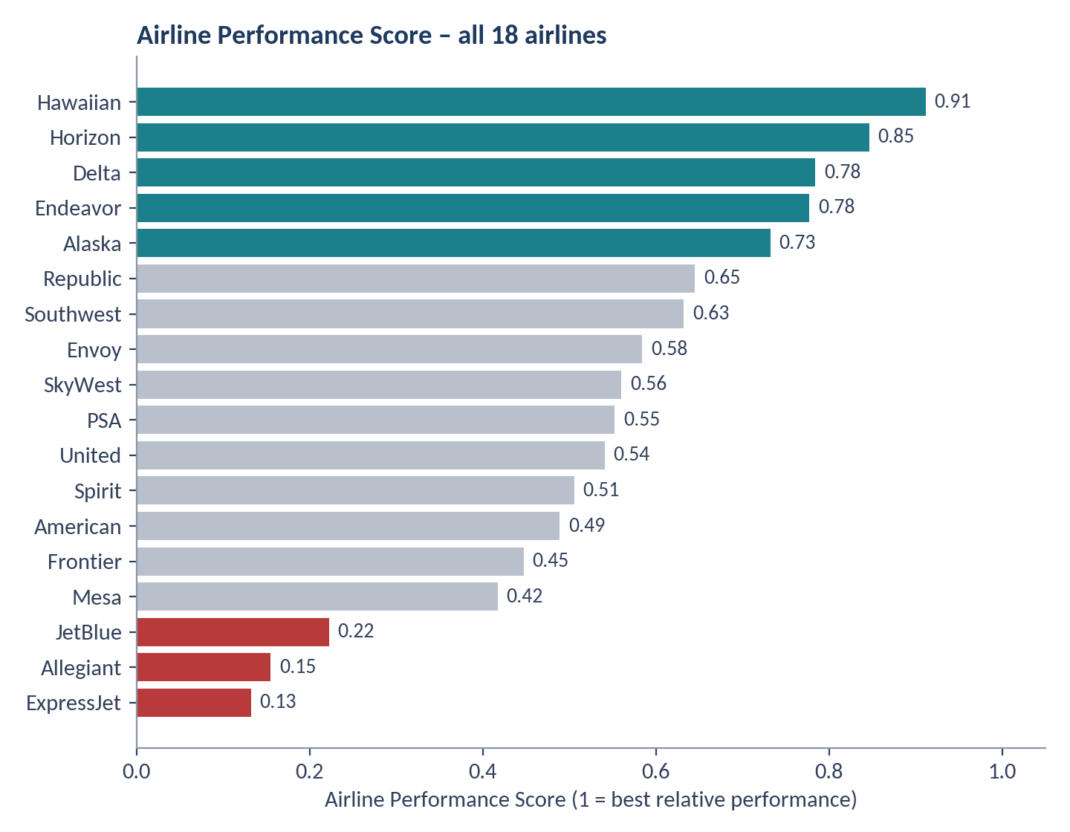
Figure 1. Airline Performance Score (teal = score of 0.70 or more, red = below 0.30)
Cross-check. The Tableau workbook scores airlines with different weights. The two methods rank airlines almost identically (Spearman rank correlation 0.92). Both put Hawaiian, Horizon, Delta, Endeavor, Alaska and Republic in the top six and JetBlue and Allegiant in the bottom two, so these conclusions do not depend on the weighting choice.

4.2 Frequency versus severity
Airlines fail in different ways, which is why a single metric is misleading. JetBlue combines the highest severe-delay rate (10.8%) with the highest average departure delay (18.3 min) and a 12.3-minute average arrival delay. Allegiant has the highest average arrival delay (13.3 min). ExpressJet has the highest cancellation rate (5.57%) and diversion rate (0.36%). Southwest stands out for volume: it flies the most flights (576,470) with a low severe-delay rate (4.7%) but a relatively high cancellation rate (3.4%).
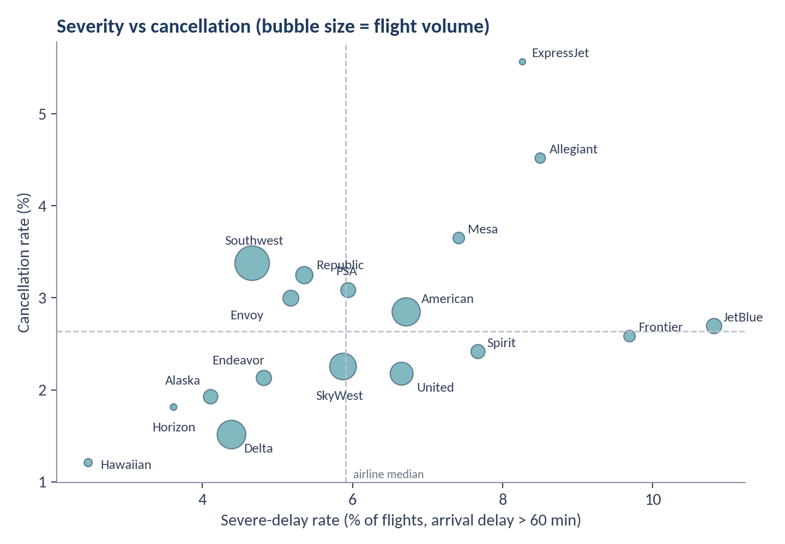
Figure 2. Severe-delay rate versus cancellation rate by airline

4.3 High volume combined with poor reliability
Impact depends on scale as well as rate. Using the dataset medians as benchmarks, five high-volume airlines show at least two poor-reliability indicators.
Airline | Flights | Avg arrival delay | Severe rate | Cancellation rate | Indicators above median
American Airlines | 383,106 | 6.66 min | 6.71% | 2.85% | 4 of 4
JetBlue Airways | 112,844 | 12.28 min | 10.82% | 2.69% | 4 of 4
United Air Lines | 254,504 | 5.04 min | 6.65% | 2.18% | 3 of 4
SkyWest Airlines | 343,737 | 4.02 min | 5.87% | 2.25% | 2 of 4
Envoy Air | 121,256 | 3.28 min | 5.18% | 3.00% | 2 of 4

American Airlines also records the most extreme delays (5,188 flights over 180 minutes), followed by SkyWest (4,585) and Delta (3,700). Part of this reflects volume, but it confirms that American is the largest single source of severe disruption. Several regional carriers fly on behalf of major airlines, so their results partly reflect the networks they serve.

5 Airport and Route Insights

5.1 Where the delay burden sits
Delay burden depends on both volume and rate. DFW generates the largest total (about 1.05 million net arrival-delay minutes), followed by DEN and ORD. Together, the top ten airports handle 30.5% of departures but about 45% of net delay minutes. ATL is the busiest airport (153,556 flights) yet performs well (2.6-minute average delay), so volume alone does not explain the burden.
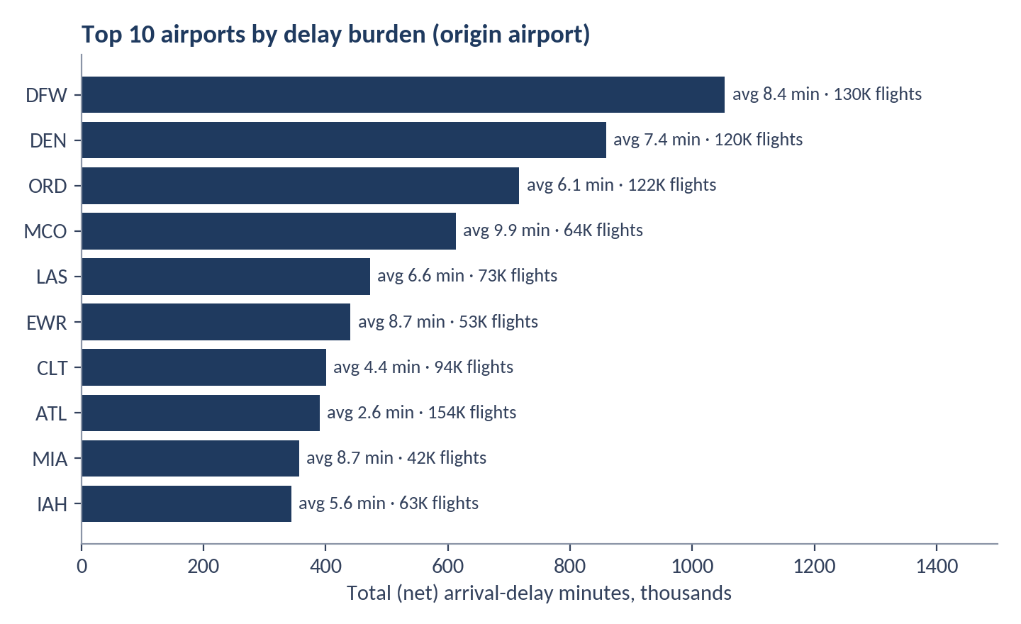
Figure 3. Top 10 airports by total (net) arrival-delay minutes, with average delay and flight volume
Large airports (at least 40,000 departures) with both average arrival delay and severe-delay rate above the network average form the priority hub list.
Airport | Flights | Avg arrival delay | Delayed rate | Severe rate | Cancellation | Net delay minutes
DFW | 130,334 | 8.38 | 36.98% | 7.23% | 3.22% | 1,053,531
ORD | 122,296 | 6.06 | 34.40% | 7.03% | 3.10% | 716,684
DEN | 119,919 | 7.38 | 38.43% | 6.73% | 2.72% | 858,837
LAS | 73,470 | 6.61 | 38.23% | 6.05% | 2.58% | 472,143
MCO | 63,883 | 9.88 | 38.74% | 8.51% | 2.73% | 612,711
IAH | 62,542 | 5.64 | 33.11% | 6.63% | 2.38% | 343,331
EWR | 52,989 | 8.67 | 36.60% | 9.13% | 3.87% | 440,310
MIA | 41,981 | 8.70 | 37.59% | 7.51% | 2.26% | 355,954
FLL | 40,276 | 8.74 | 36.74% | 8.28% | 2.70% | 341,669
Network average | – | 4.26 | 32.60% | 5.84% | 2.64% | –

5.2 Smaller airports with concentrated problems
The project's Airport Risk Score, applied to all 380 origin airports, ranks tiny airports first (ART with 21 flights, OGD with 18, HYA with 50) because a handful of flights can produce extreme percentages. These results are not statistically reliable. Restricting the score to the 198 airports with at least 1,000 flights gives a more useful list:
Airport | Flights | Avg arrival delay | Severe rate | Disruption rate | Risk score
ASE (Aspen) | 2,859 | 22.21 min | 12.56% | 9.90% | 0.97
SFB | 4,581 | 10.47 min | 7.29% | 5.57% | 0.64
PGD | 2,854 | 10.39 min | 8.13% | 4.70% | 0.64
EWR | 52,989 | 8.67 min | 9.13% | 4.12% | 0.62
EGE | 1,325 | 12.12 min | 8.45% | 5.66% | 0.62
EYW | 3,493 | 10.96 min | 7.19% | 4.09% | 0.60
MCO | 63,883 | 9.88 min | 8.51% | 2.91% | 0.59

ASE is the clear outlier: a 22-minute average delay and nearly 10% of flights cancelled or diverted. Its low volume means the response can be targeted rather than network-wide. EWR and MCO appear on both the large-airport list and the risk list, which makes them the strongest candidates for a bottleneck review.

5.3 Routes
Route results were also volume-adjusted. Ranking all routes with 100 or more flights surfaces thin samples such as RNO→JFK (47.4-minute average delay on 101 flights) and ABQ→JFK (40.1 minutes on 116 flights); these are useful watch items but too small to act on alone. Restricting to the 2,018 routes with at least 500 flights gives a firmer priority list.
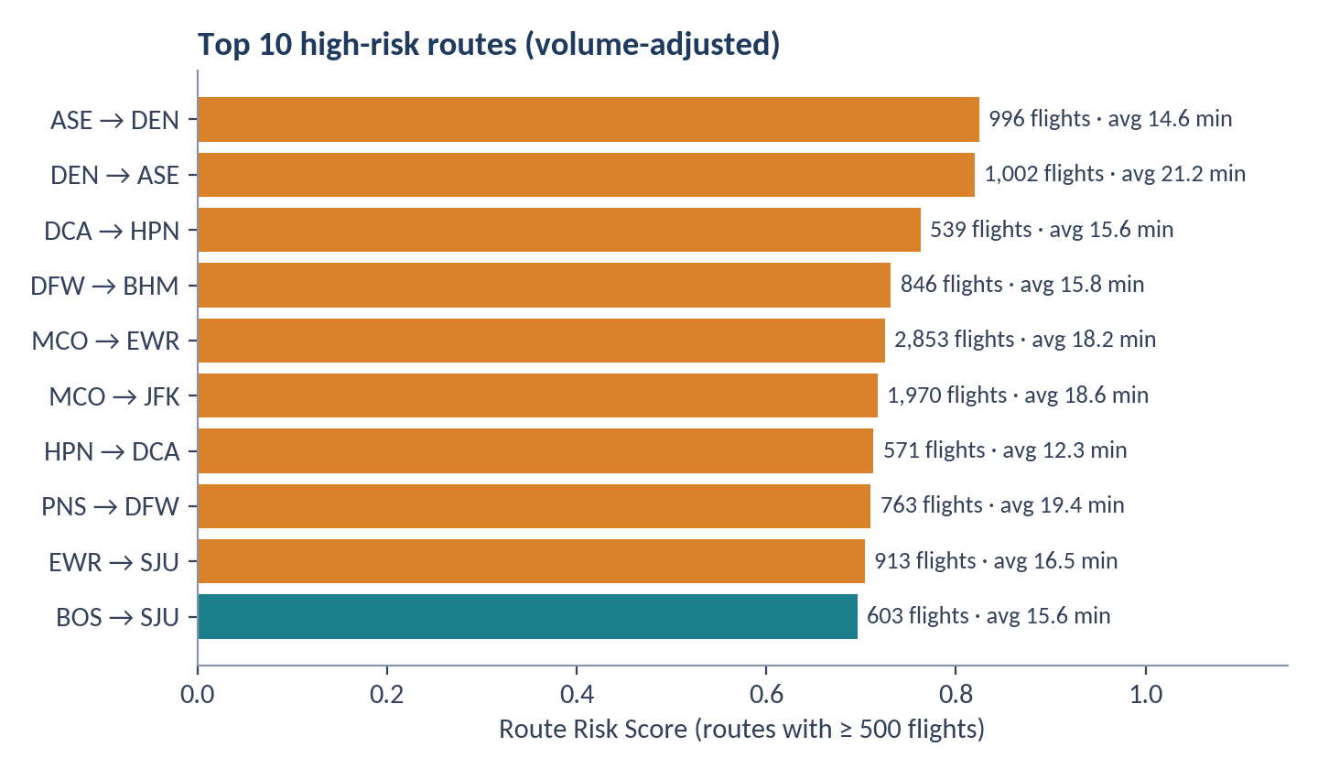
Figure 4. Top 10 routes by Route Risk Score among routes with at least 500 flights
Three patterns stand out. Aspen (DEN↔ASE) combines delays with disruption: 21.2 minutes average delay into ASE from Denver and about 9% cancelled or diverted. New York-area airports (EWR, JFK) appear on the Florida and Caribbean corridors, such as MCO→EWR (18.2 min, 12.4% severe) and MCO→JFK (18.6 min, 13.4% severe). San Juan routes (EWR↔SJU, BOS→SJU) have delayed-flight rates of 47–48%, the highest in the top ten. The Tableau route risk score (Dashboard 3) surfaces largely the same routes.

6 Root-Cause Findings
Delay causes are recorded in five categories. The shares below describe recorded delay minutes, not the share of flights, and the cause fields are populated for 533,863 flights (about 18% of flights with an arrival time), consistent with delayed flights.
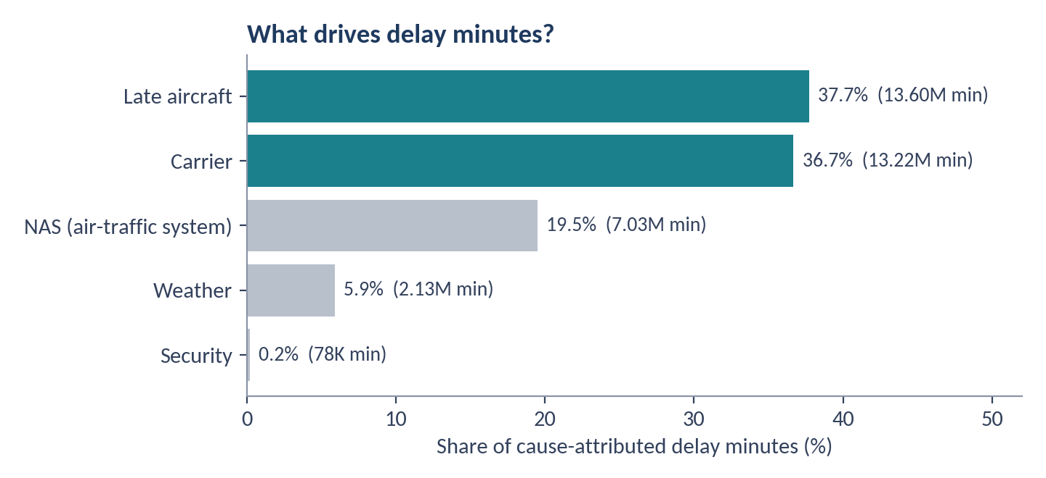
Figure 5. Share of cause-attributed delay minutes (36.05 million minutes in total)
Late aircraft (37.7%) and carrier (36.7%) together explain 74.4% of delay minutes. Late-aircraft delay means a flight left late because the aircraft arrived late from its previous flight, so a delay at one point travels through the day. NAS delay adds 19.5%, weather 5.9% and security only 0.2%. Weather is therefore a minor driver of delay minutes (though it is the largest recorded reason for cancellations).

Delay profile differs by airline
Dominant cause | Airlines (share of the airline's delay minutes)
Late aircraft (12 airlines) | Southwest 48.2%, PSA 47.1%, Frontier 44.9%, Allegiant 42.4%, American 41.5%, United 40.6%, Horizon, Mesa, Envoy, Endeavor, Alaska, Republic
Carrier (4 airlines) | Hawaiian 56.3%, SkyWest 51.6%, Delta 46.1%, JetBlue 40.4%
NAS / air-traffic system (2 airlines) | Spirit 38.1%, ExpressJet 36.9%

Weather weighs most for the regional carriers SkyWest (12.4%), Envoy (11.5%) and Mesa (9.1%). Airports differ too: carrier delay is the largest share at ATL (46.2%), JFK (44.4%), LAX (42.0%) and DEN (41.0%); late aircraft dominates at BUR (49.3%), CLT (42.1%) and DFW (41.7%); and NAS delay is unusually high at CVG (28.4%). By season, the late-aircraft share is highest in summer (39.5%) and the weather share is highest in winter (6.9%).
Management reading: most delay minutes sit in causes that an airline can influence through scheduling, turnaround and aircraft rotation. Because late-aircraft delay is partly a knock-on effect of earlier carrier, NAS or weather problems, fixing early-day punctuality and adding recovery buffers should reduce both categories.

7 Time and Seasonality

7.1 Year over year
Year | Flights | Avg departure delay | Avg arrival delay | Delayed rate | Cancellation | Diversion
2019 | 757,673 | 10.81 | 5.31 | 33.67% | 1.79% | 0.26%
2020 | 479,350 | 2.03 | −5.01 | 20.47% | 6.00% | 0.16%
2021 | 611,633 | 9.39 | 3.10 | 32.03% | 1.72% | 0.23%
2022 | 687,860 | 12.50 | 6.91 | 36.24% | 2.68% | 0.24%
2023 (Jan–Aug) | 463,484 | 14.47 | 9.37 | 38.79% | 1.68% | 0.27%

2020 is an outlier: traffic collapsed during the pandemic, skies were emptier and average arrival delay fell below zero, while cancellations hit 6.0%. Since 2021 delays have risen every year. The 2023 data stops in August, so for a fair comparison use January–August only: average arrival delay was 3.2 min in 2021, 7.7 min in 2022 and 9.4 min in 2023, still the worst of the period.

7.2 Month and season
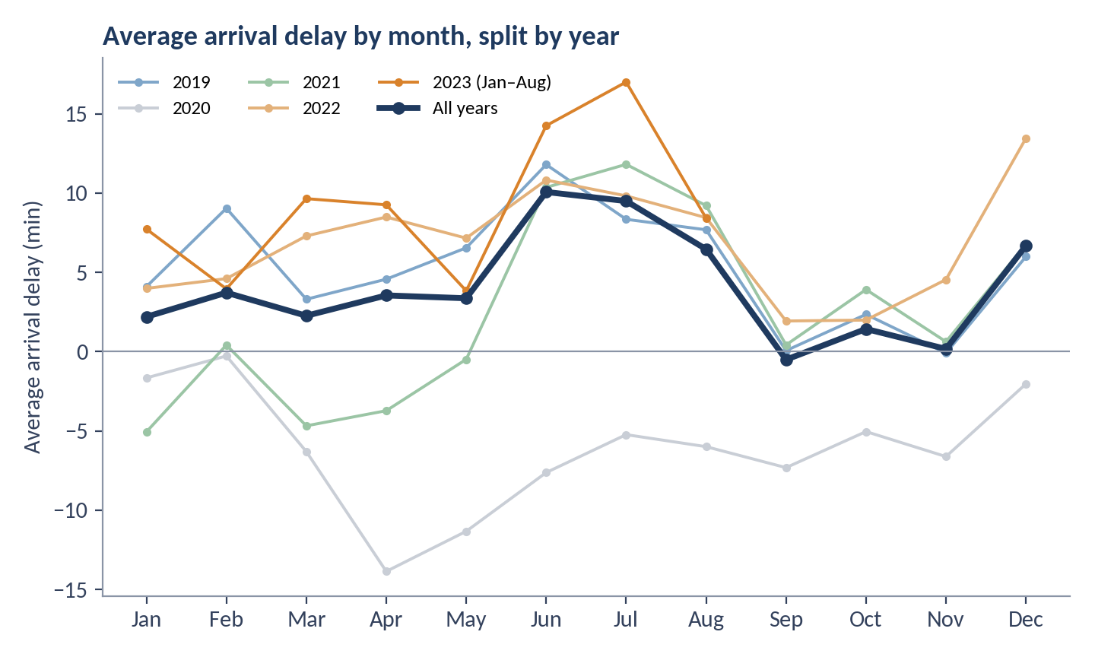
Figure 6. Average arrival delay by month; the bold line is the all-years average
June (10.1 min, 38.8% of flights delayed) and July (9.5 min, 37.1%) are the highest-risk months, and June ranks first or second in 2019, 2021, 2022 and 2023. December follows (6.7 min), driven by December 2022 at 13.5 minutes, the worst December in the data. September (−0.5 min) and November (0.2 min) are the calmest months. Cancellations peak in April (6.85%) and March (5.03%) only because of 2020: April 2020 saw 41.6% of flights cancelled, and April without 2020 is 1.8%.
Season | Flights | Avg departure delay | Avg arrival delay | Delayed rate | Cancellation | Diversion
Winter | 732,588 | 10.18 | 4.03 | 32.96% | 2.72% | 0.22%
Spring | 799,546 | 9.08 | 3.01 | 30.91% | 4.56% | 0.22%
Summer | 833,208 | 13.81 | 8.62 | 36.63% | 1.93% | 0.32%
Fall | 634,658 | 6.52 | 0.37 | 29.05% | 1.05% | 0.17%

7.3 Day of week
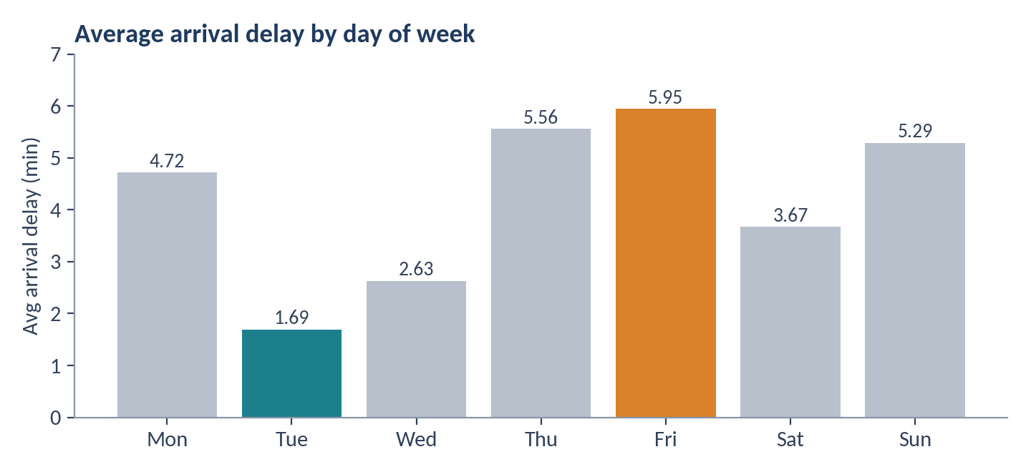
Figure 7. Average arrival delay by day of week
Friday is the worst weekday (5.95 min, 35.1% delayed), followed by Thursday (5.56) and Sunday (5.29). Tuesday is the best (1.69 min). Friday stays the worst weekday and Tuesday the best even if 2020 is excluded (7.7 vs 3.2 min), so this is not a pandemic artefact.

8 Tableau Dashboards
The Tableau workbook contains 25 worksheets arranged into four dashboards that mirror the project requirements. All four use the same cleaned dataset and share common KPI cards.
Dashboard | Purpose | Main views
1 Executive Overview | One-page view of network health for executives | KPI cards (flights, airlines, average delay, cancellation, diversion), airline ranking, delay trend, flight-volume trend
2 Airline Performance | Benchmark airlines and find weak spots | Airline scorecard, benchmarking, frequency versus severity, cancellation and diversion, airline drill-down
3 Airport & Route Intelligence | Locate delay hotspots geographically and by route | Airport performance, top delayed routes, high-risk routes, origin-destination comparison, route detail
4 Delay Causes & Trends | Explain why and when delays occur | Cause contribution, cause by airline and airport, monthly and seasonal trends, operational hotspots

Two points to be aware of before presenting the workbook. First, the Route Risk Score is scaled 0–100 with High Risk at 75 or above, but among routes with at least 100 flights only one route reaches even the Medium threshold of 50, so the category colouring is nearly uniform; lowering the thresholds or normalising scores would make the view more useful. Second, the Airline Performance Score in Tableau is compressed into a narrow band (about 90 to 99) because it scales delay by a fixed 60 minutes, which makes airlines look more alike than they are.

9 Recommendations
The recommendations below are descriptive and diagnostic. They point to where operational review will pay off most, and they do not prove that a specific intervention will reduce delay.
# | Recommendation | Evidence | Suggested KPI to track
1 | Protect aircraft rotations. Add schedule buffers on tight turns and set early-day recovery rules, starting with airlines where late aircraft is the main cause. | Late aircraft = 37.7% of delay minutes; Southwest 48.2%, PSA 47.1%, Frontier 44.9% | Late-aircraft delay minutes per flight
2 | Review carrier-controlled processes (ground handling, crew, maintenance, servicing) at airlines where carrier delay dominates. | Carrier = 36.7%; Hawaiian 56.3%, SkyWest 51.6%, Delta 46.1%, JetBlue 40.4% | Carrier delay minutes per flight
3 | Run airline-specific reviews for high-volume, low-score carriers: American, JetBlue and United first, then SkyWest and Envoy. Set a target such as bringing severe-delay rate to the airline median (5.9%). | American 6.7%, JetBlue 10.8%, United 6.7% severe rate; American has the most delays over 180 min | Severe-delay rate; Airline Performance Score
4 | Investigate cancellation reliability at ExpressJet, Allegiant and Mesa, whose cancellation rates are well above the 2.6% median. | ExpressJet 5.57%, Allegiant 4.52%, Mesa 3.65% | Cancellation rate
5 | Build a summer readiness plan before June: extra staffing, spare aircraft and tighter turnaround management in June–August. | Summer 8.6 min vs fall 0.4 min; June 10.1 min; late-aircraft share peaks in summer | Avg arrival delay in June–Aug
6 | Start a hub bottleneck programme at DFW, DEN and ORD (largest totals) and EWR, MCO, FLL and MIA (worst rates). | Ten airports = 30.5% of flights, about 45% of net delay minutes | Net delay minutes; severe-delay rate by airport
7 | Create a route watchlist and review scheduled block times on DEN↔ASE, MCO→EWR, MCO→JFK, EWR↔SJU, PNS→DFW and DFW→BHM. | Top-10 routes (≥ 500 flights) show 10–13% severe rates and up to 18.6 min average delay | Route risk score; on-time rate by route
8 | Plan around high-risk days: strengthen readiness on Fridays and Thursdays and before the December peak. | Friday 5.95 vs Tuesday 1.69 min; December 2022 at 13.5 min | Avg arrival delay by weekday and month
9 | Focus on on-time departure. Track on-time pushback and taxi-out performance as the lead indicators. | Departure vs arrival delay r = 0.965; distance r = 0.002 | Departure delay; share of on-time departures

10 Limitations and Next Steps

Limitations
- Time coverage. Data runs from January 2019 to August 2023. September–December have only four years of data, and 2020 is distorted by the pandemic (arrival delay −5.0 min, 6.0% cancellations).
- Cause data is partial. Cause fields exist for about 18% of flights with an arrival time and describe recorded delay minutes, not all flights. Late-aircraft delay is partly a consequence of other causes, so the five categories are not fully independent.
- Scores are relative and assumption-based. Equal weights are a baseline, min-max scaling is sensitive to extreme values, and scores compare entities within this dataset only. Small airports and routes can look extreme on few flights; this report applies volume filters (airports ≥ 1,000, routes ≥ 500 flights) to reduce that.
- Definitions differ slightly between Python and Tableau (Section 2.5), and Tableau's scoring thresholds need recalibration.
- Origin-based airport view. Airport figures use the departure airport; arrival-airport congestion is not isolated. Regional carriers operate for major airlines, so brand-level conclusions are partly network effects.
- Descriptive, not causal. The analysis identifies where and when problems concentrate. It cannot prove that a cause or intervention changes delay.

Next steps
- Complete the MySQL layer (KPI queries, rankings with window functions, month-over-month changes) and reconcile results with this report.
- Run a weight sensitivity test (for example 40/30/20/10) to confirm that airline and airport rankings are stable.
- Add time-of-day analysis using scheduled departure time to test how delay builds through the day.
- Align metric definitions and thresholds between Python and Tableau, and publish the dashboards with a short user guide.
- Extend the dataset beyond August 2023 and separate 2020 in trend and seasonality views.

Appendix A Airline Scorecard
Airlines are ranked by the Airline Performance Score (equal weights, higher is better). The last column shows the rank from the Tableau scoring formula as a cross-check. Severe rate is the share of all flights with arrival delay above 60 minutes.
Rank | Airline | Flights | Avg arr. delay (min) | Severe rate | Cancel rate | Diversion rate | Score | Tableau rank
1 | Hawaiian Airlines | 32,114 | 3.89 | 2.48% | 1.21% | 0.087% | 0.911 | 6
2 | Horizon Air | 20,634 | 2.38 | 3.62% | 1.81% | 0.112% | 0.847 | 5
3 | Delta Air Lines | 395,239 | 1.09 | 4.39% | 1.51% | 0.198% | 0.784 | 2
4 | Endeavor Air | 112,463 | -1.26 | 4.82% | 2.13% | 0.196% | 0.777 | 1
5 | Alaska Airlines | 100,467 | 1.10 | 4.11% | 1.92% | 0.238% | 0.732 | 3
6 | Republic Airline | 143,107 | 0.59 | 5.36% | 3.25% | 0.219% | 0.645 | 4
7 | Southwest Airlines | 576,470 | 3.27 | 4.66% | 3.38% | 0.197% | 0.632 | 7
8 | Envoy Air | 121,256 | 3.28 | 5.18% | 3.00% | 0.256% | 0.584 | 8
9 | SkyWest Airlines | 343,737 | 4.02 | 5.87% | 2.25% | 0.293% | 0.560 | 9
10 | PSA Airlines | 107,050 | 3.93 | 5.94% | 3.08% | 0.248% | 0.552 | 10
11 | United Air Lines | 254,504 | 5.04 | 6.65% | 2.18% | 0.274% | 0.541 | 11
12 | Spirit Air Lines | 95,711 | 8.03 | 7.67% | 2.42% | 0.208% | 0.505 | 14
13 | American Airlines | 383,106 | 6.66 | 6.71% | 2.85% | 0.256% | 0.489 | 12
14 | Frontier Airlines | 64,466 | 11.10 | 9.69% | 2.58% | 0.136% | 0.447 | 16
15 | Mesa Airlines | 65,012 | 7.31 | 7.42% | 3.65% | 0.249% | 0.417 | 13
16 | JetBlue Airways | 112,844 | 12.28 | 10.82% | 2.69% | 0.317% | 0.222 | 17
17 | Allegiant Air | 52,738 | 13.28 | 8.50% | 4.52% | 0.334% | 0.155 | 18
18 | ExpressJet Airlines | 19,082 | 10.03 | 8.26% | 5.57% | 0.362% | 0.132 | 15

Green rows are the three highest scores and red rows the three lowest.

